Hedpac.org - Empowering Health Partnerships for a Brighter Future

Hedpac.org serves as a cornerstone for health partnership initiatives between Carbinas and Africa, and its website plays a pivotal role in fostering collaboration and driving positive change. As the developer behind this impactful platform, I focused on creating a dynamic online hub that facilitates communication and resource sharing among stakeholders.

The website's design is clean and professional, with a user-friendly interface that allows visitors to access information about ongoing projects, events, and resources with ease. Clear navigation pathways ensure that users can quickly find the information they need, fostering engagement and participation.

website link <http://www.hedpac.org/>

images

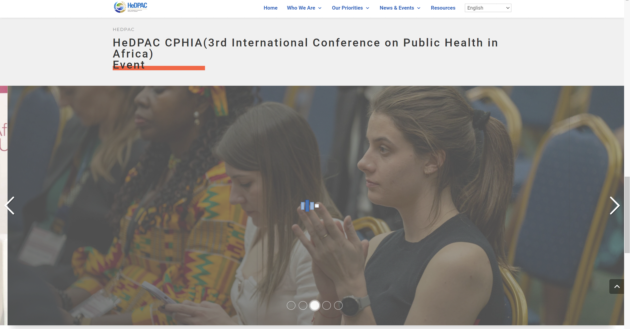

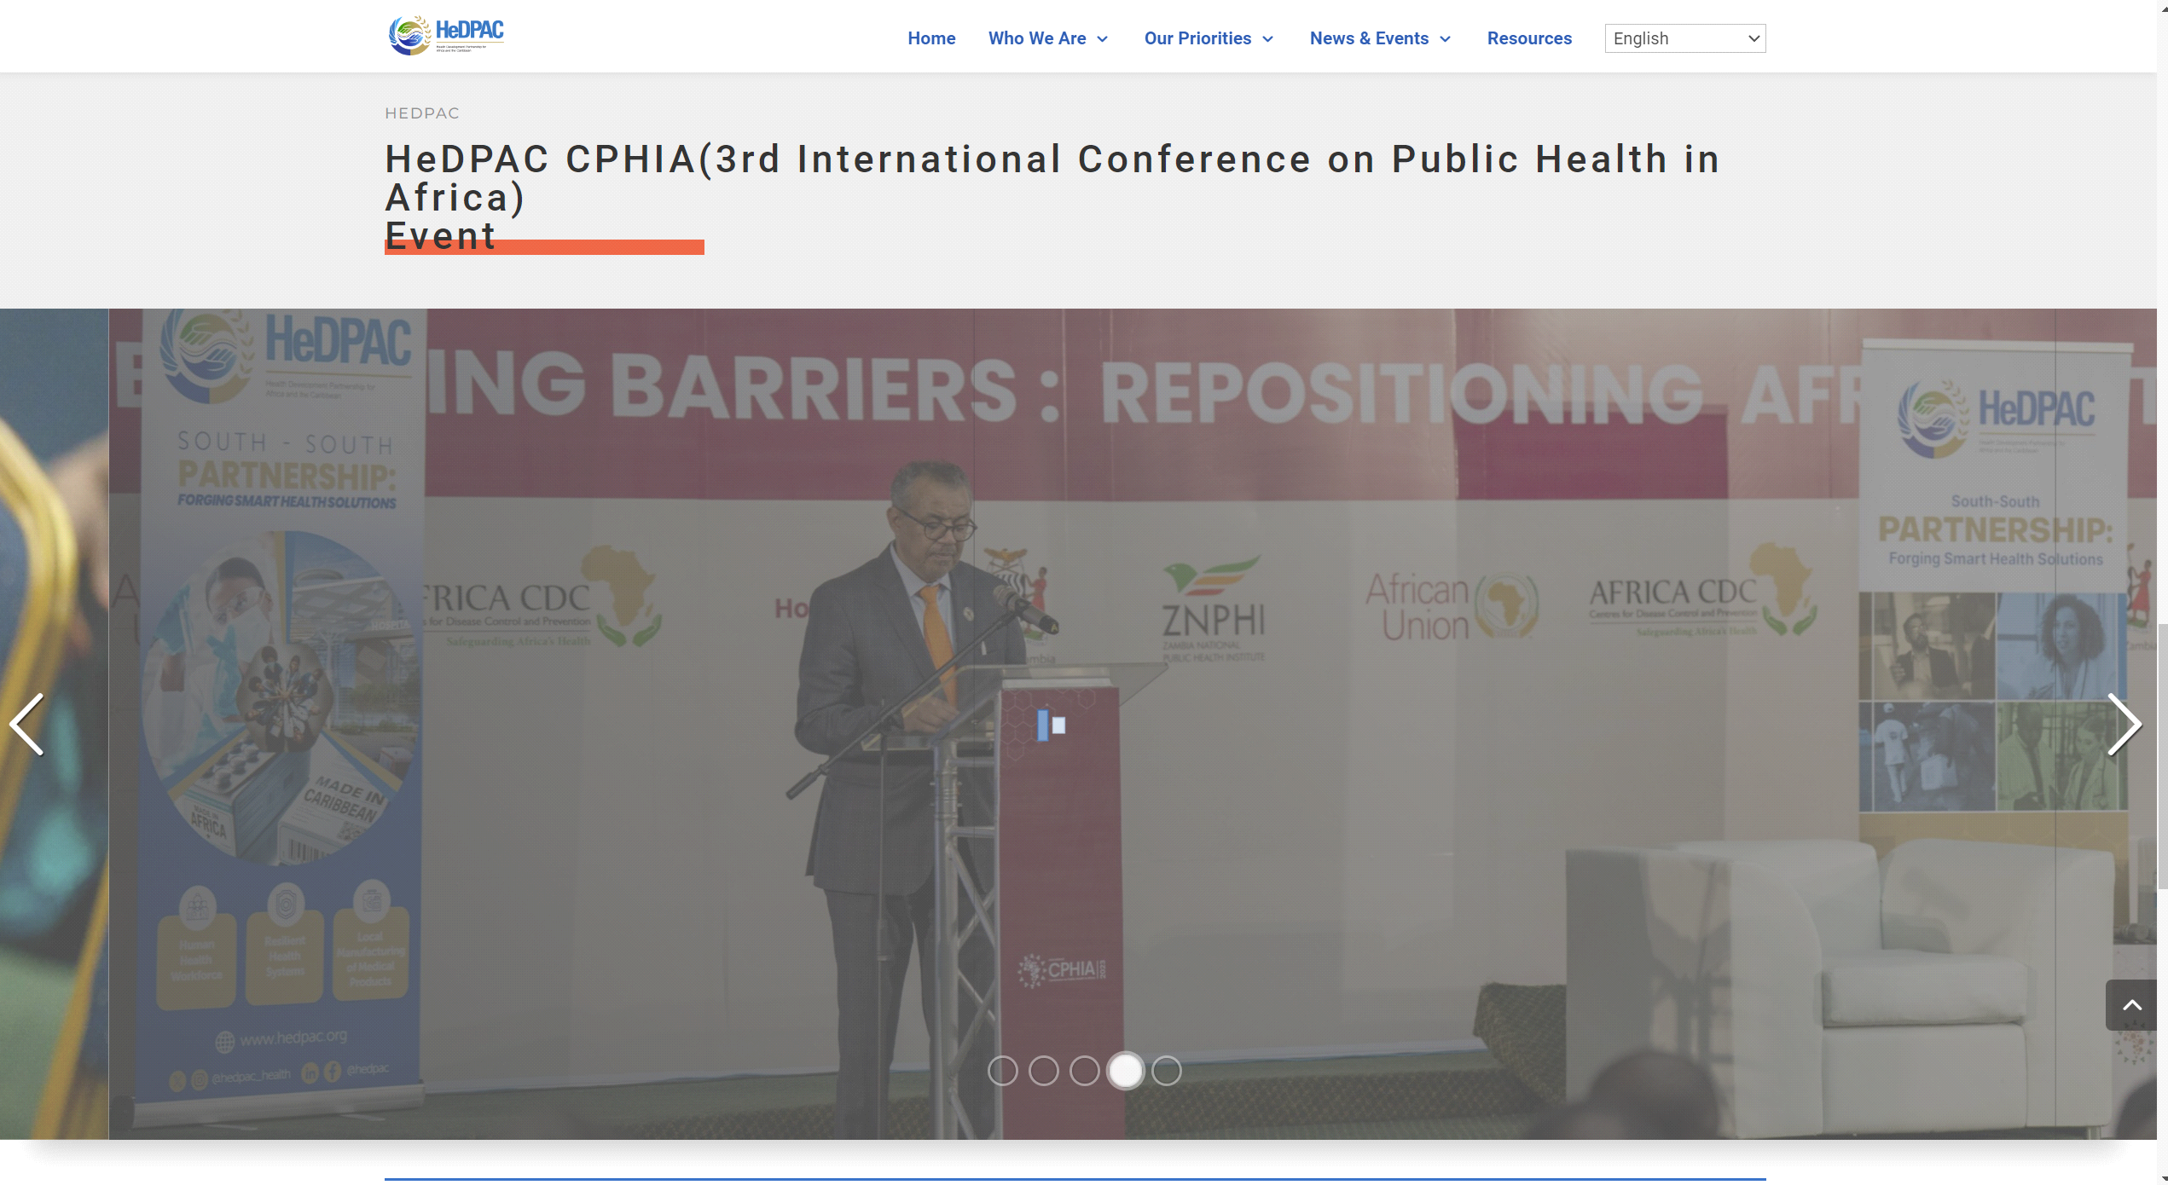

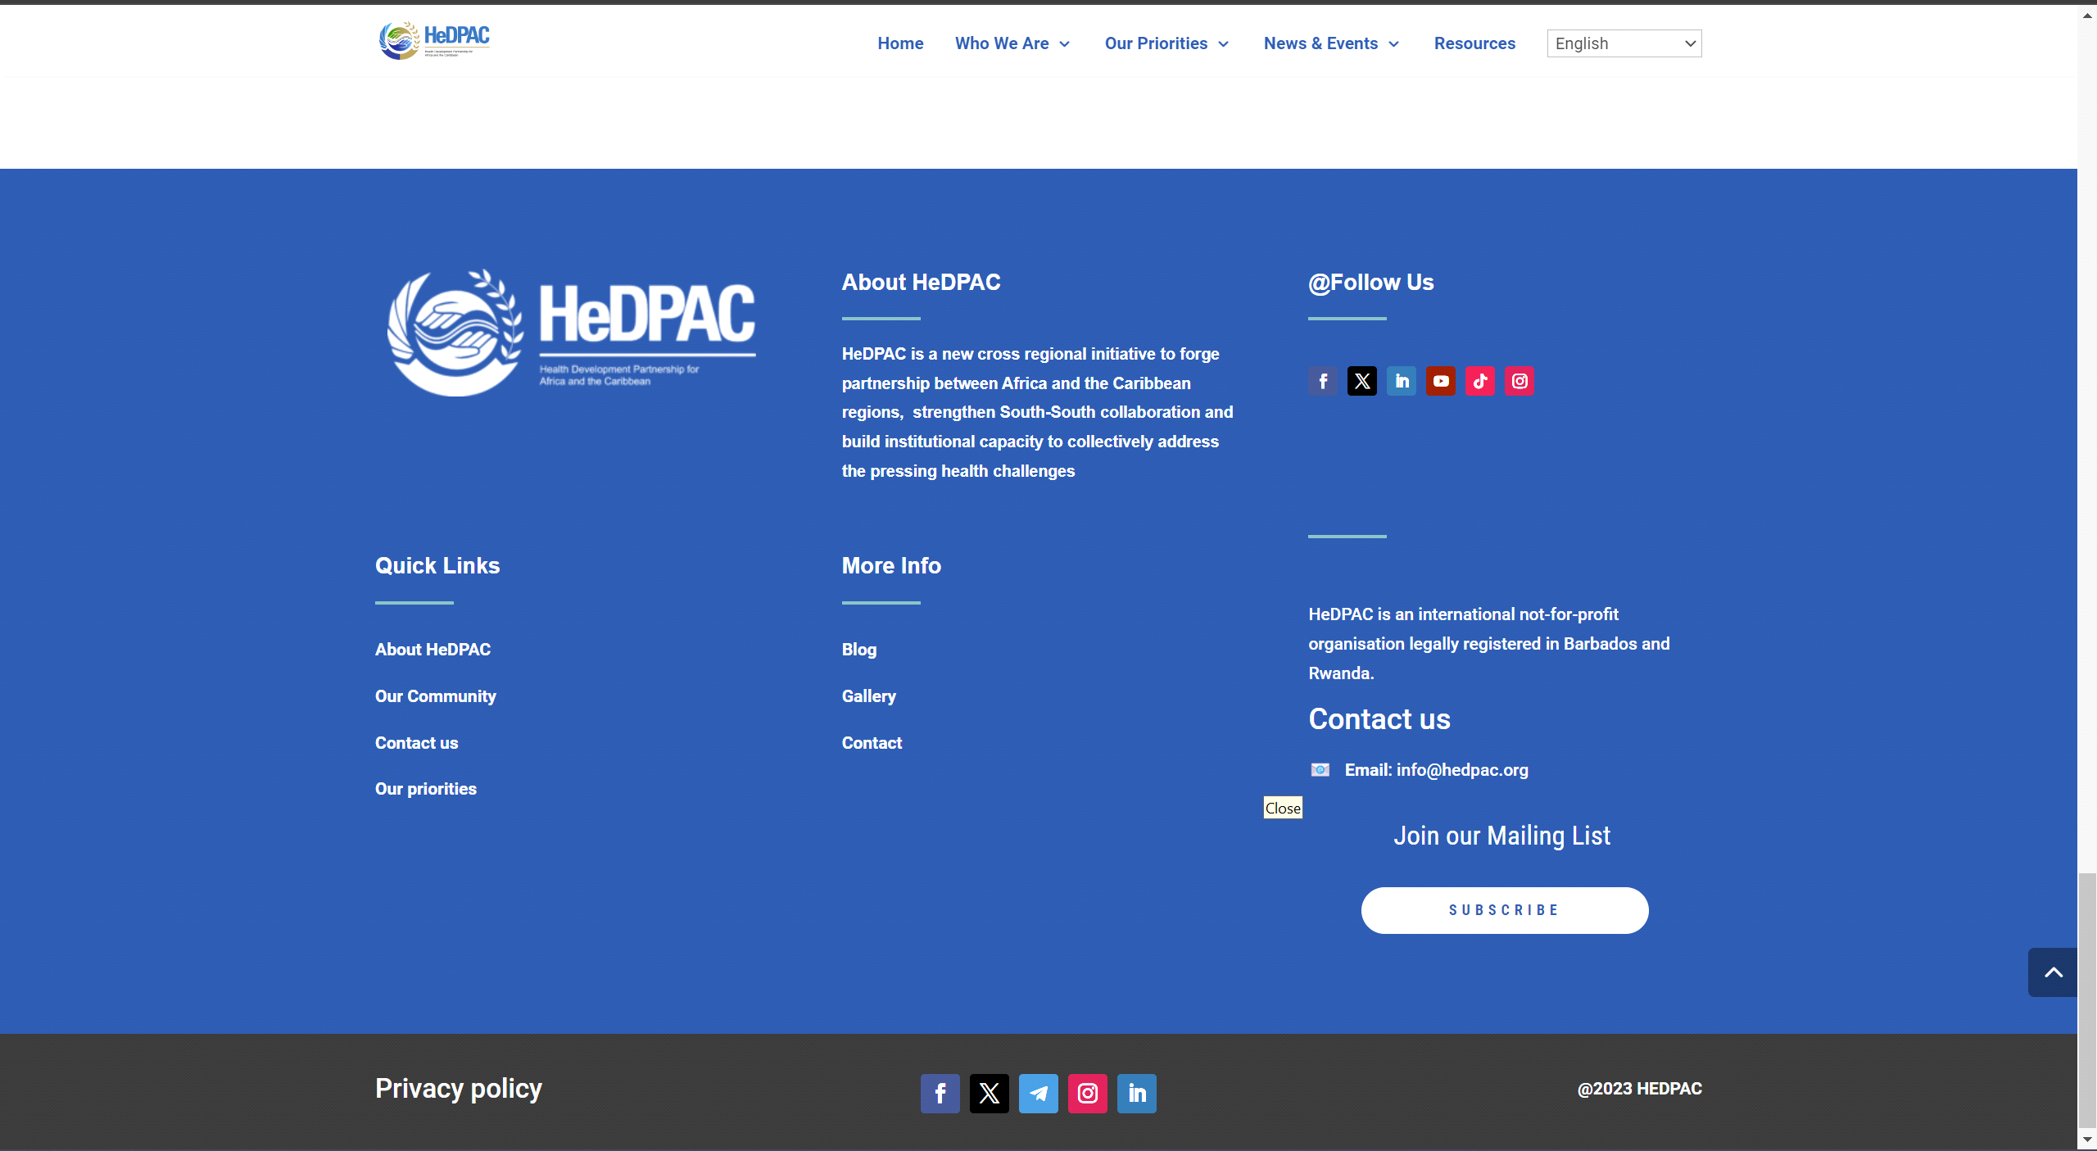

In conclusion, Hedpac.org's website serves as a catalyst for advancing health partnerships and improving healthcare outcomes in Africa, and I am privileged to have contributed to its development.

Grand Palace Addis - A Digital Gateway to Luxury Hospitality

Grand Palace Addis stands as a beacon of luxury hospitality in the heart of Addis Ababa, and their website reflects this esteemed reputation. As the developer behind this prestigious platform, I aimed to create a digital gateway that captures the essence of the hotel's elegance and sophistication.

The website's design exudes luxury, with rich imagery showcasing the hotel's exquisite accommodations, amenities, and dining experiences. Seamless navigation allows visitors to explore room options, book reservations, and learn about exclusive offers with ease.

By integrating interactive features such as virtual tours and guest testimonials, the website provides a captivating glimpse into the unparalleled experience awaiting guests at Grand Palace Addis. Mobile responsiveness ensures accessibility across all devices, ensuring a seamless browsing experience for potential guests.

In essence, Grand Palace Addis' website serves as a compelling invitation to indulge in the ultimate luxury hospitality experience, and I am honored to have played a part in its creation.

website link <https://grandpalaceaddis.com/>   
images

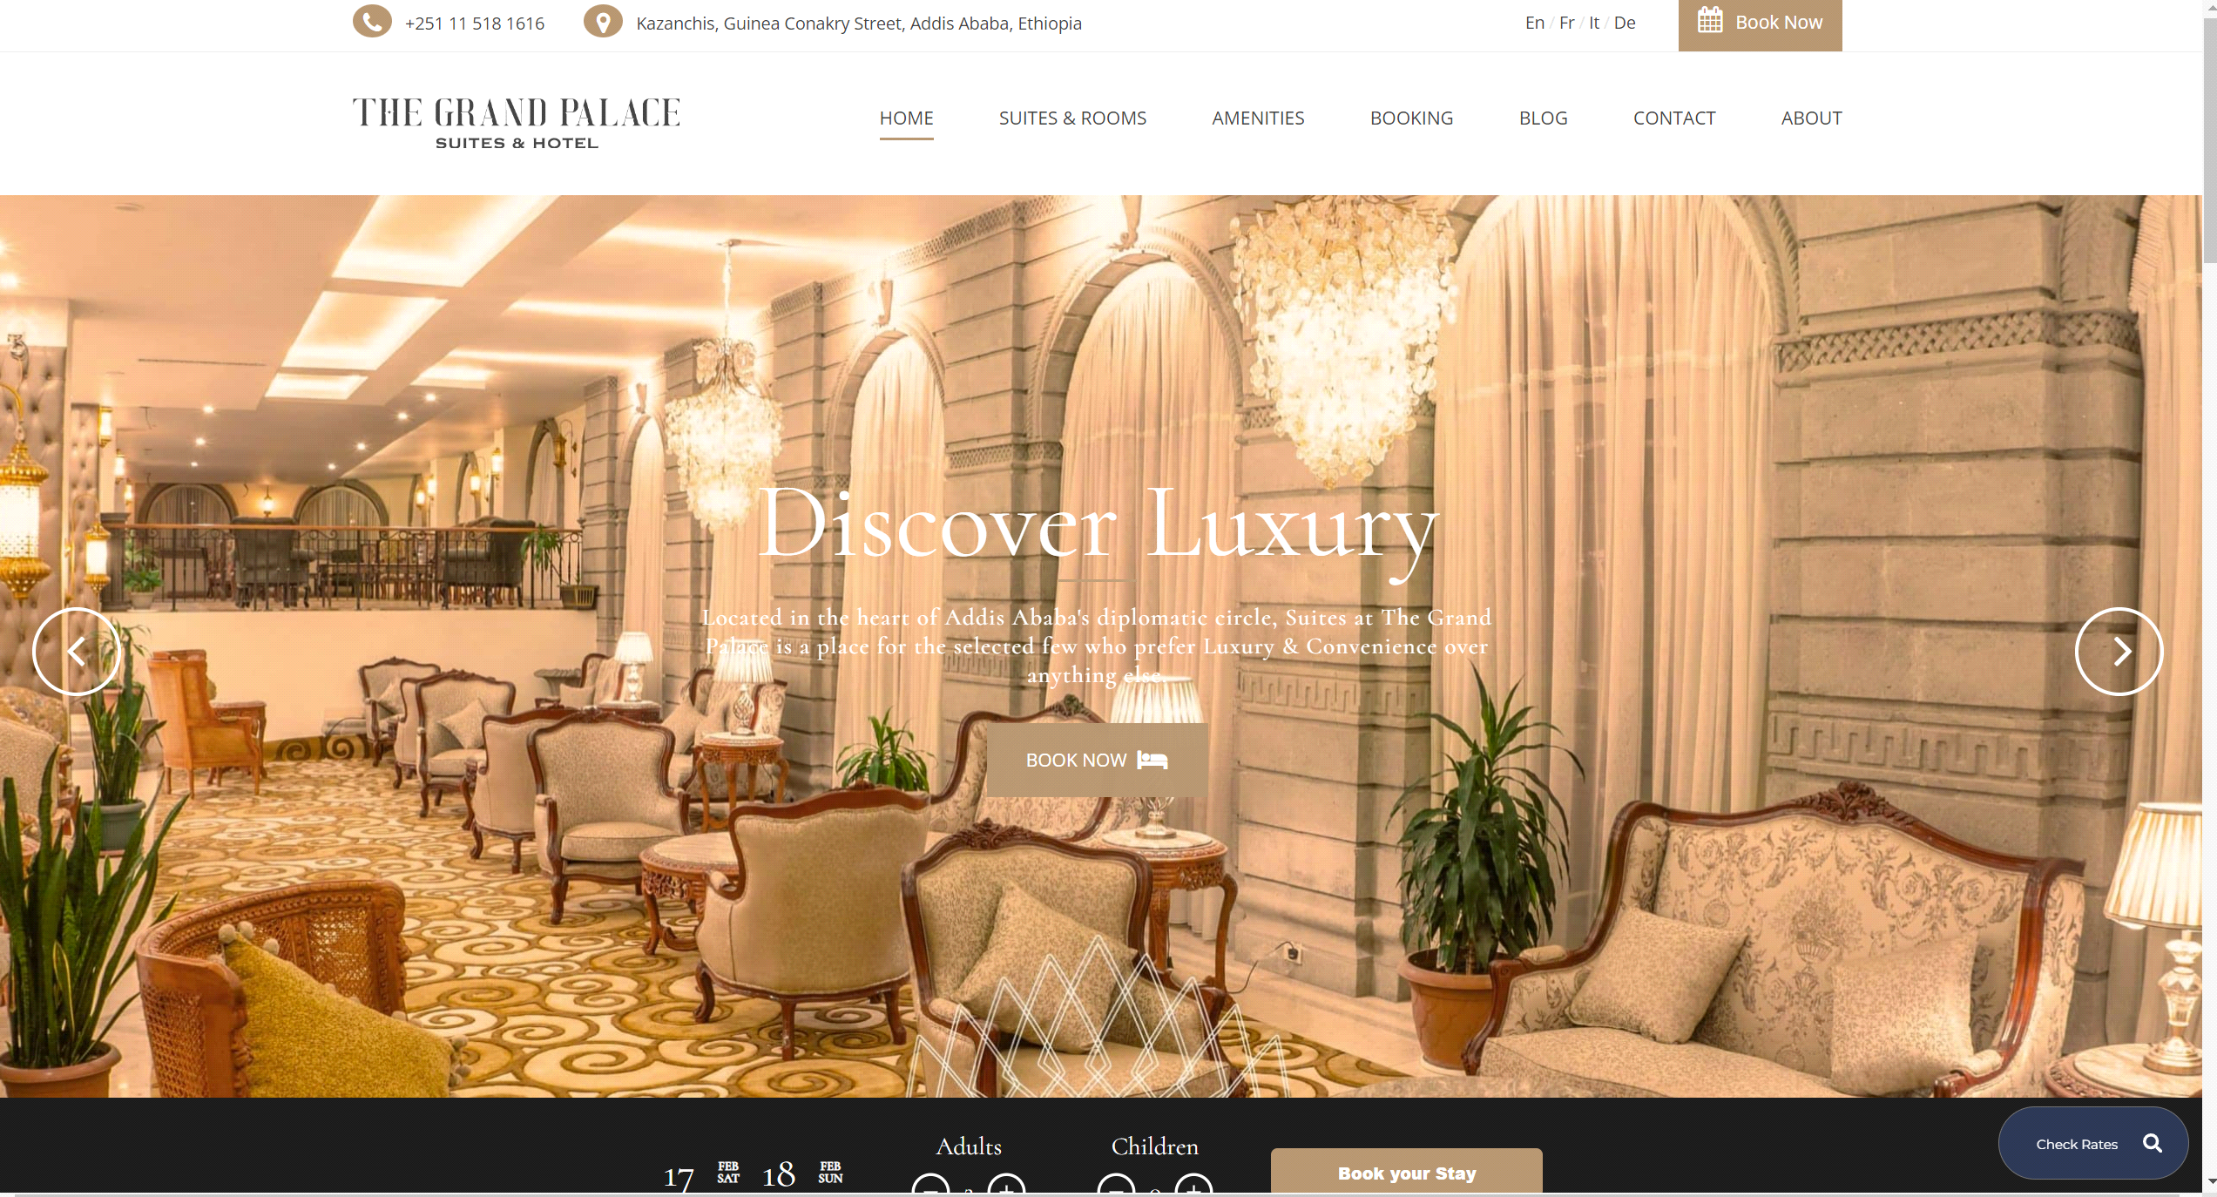

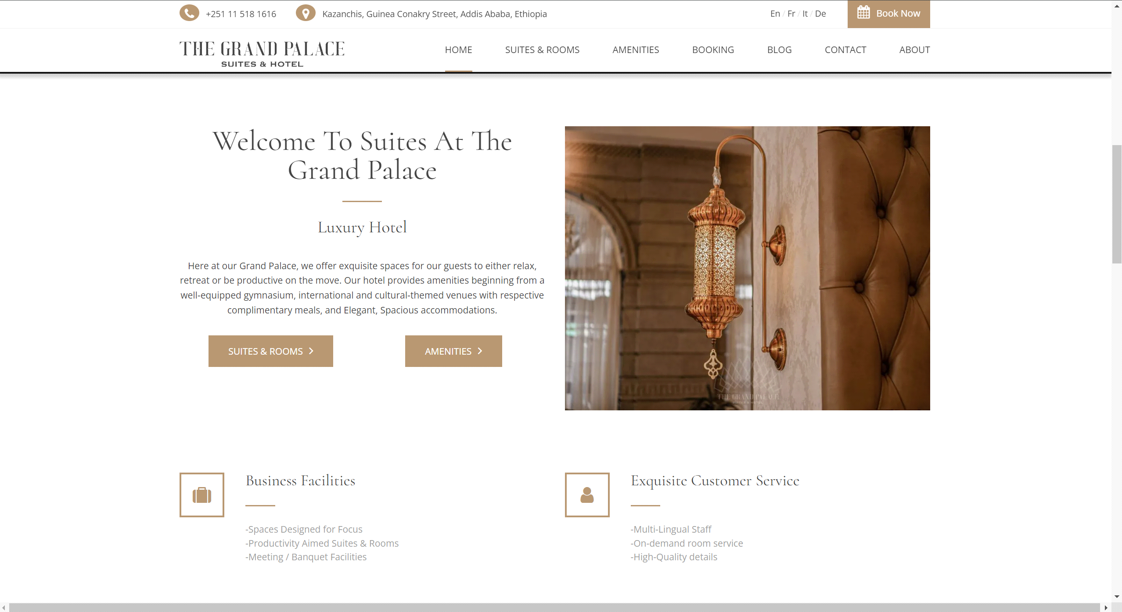

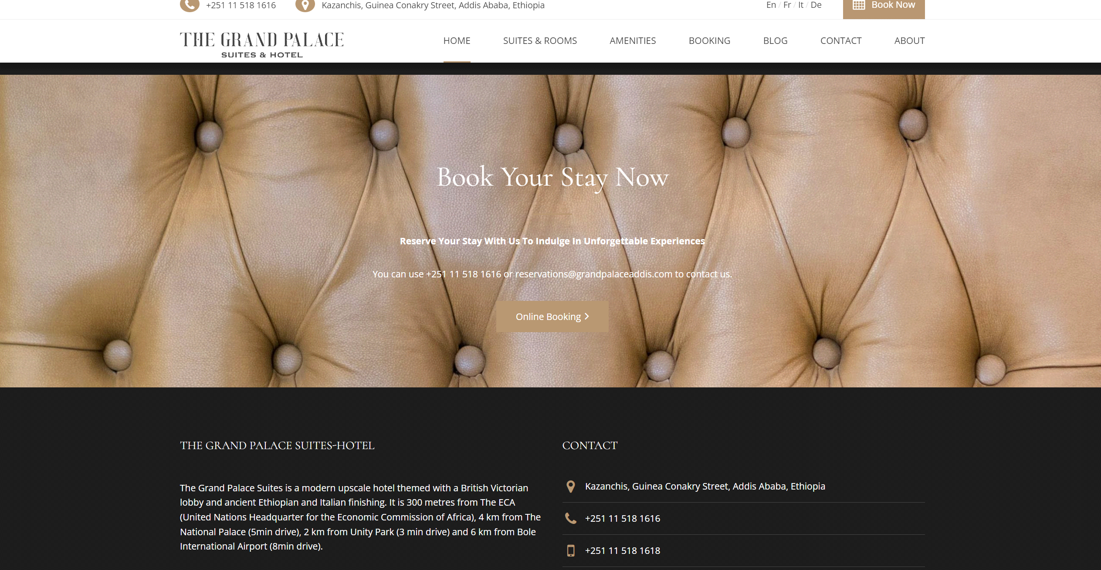

Axis Advocates - Navigating Legal Solutions with Confidence

Axis Advocates is a reputable law firm dedicated to providing expert legal counsel and representation, and their website serves as a cornerstone of their online presence. As the developer behind this esteemed platform, I aimed to create a professional and informative website that instills trust and confidence in potential clients.

The website's design exudes professionalism, with a clean and modern layout that conveys the firm's expertise and reliability. Clear navigation menus and intuitive search functionality enable visitors to easily find information about the firm's practice areas, attorneys, and recent case studies.

Interactive features such as contact forms and live chat support facilitate communication between clients and attorneys, streamlining the process of seeking legal assistance. Integration with scheduling software allows clients to book consultations online, providing convenience and flexibility.

By incorporating client testimonials and success stories, the website showcases the firm's track record of delivering favorable outcomes and building long-lasting client relationships. Mobile responsiveness ensures that the website remains accessible and functional across all devices, catering to the needs of modern clients.

In conclusion, Axis Advocates' website serves as a valuable resource for individuals and businesses seeking expert legal guidance, and I am proud to have played a role in its development.

website link <https://axisadvocates.com/>  
images

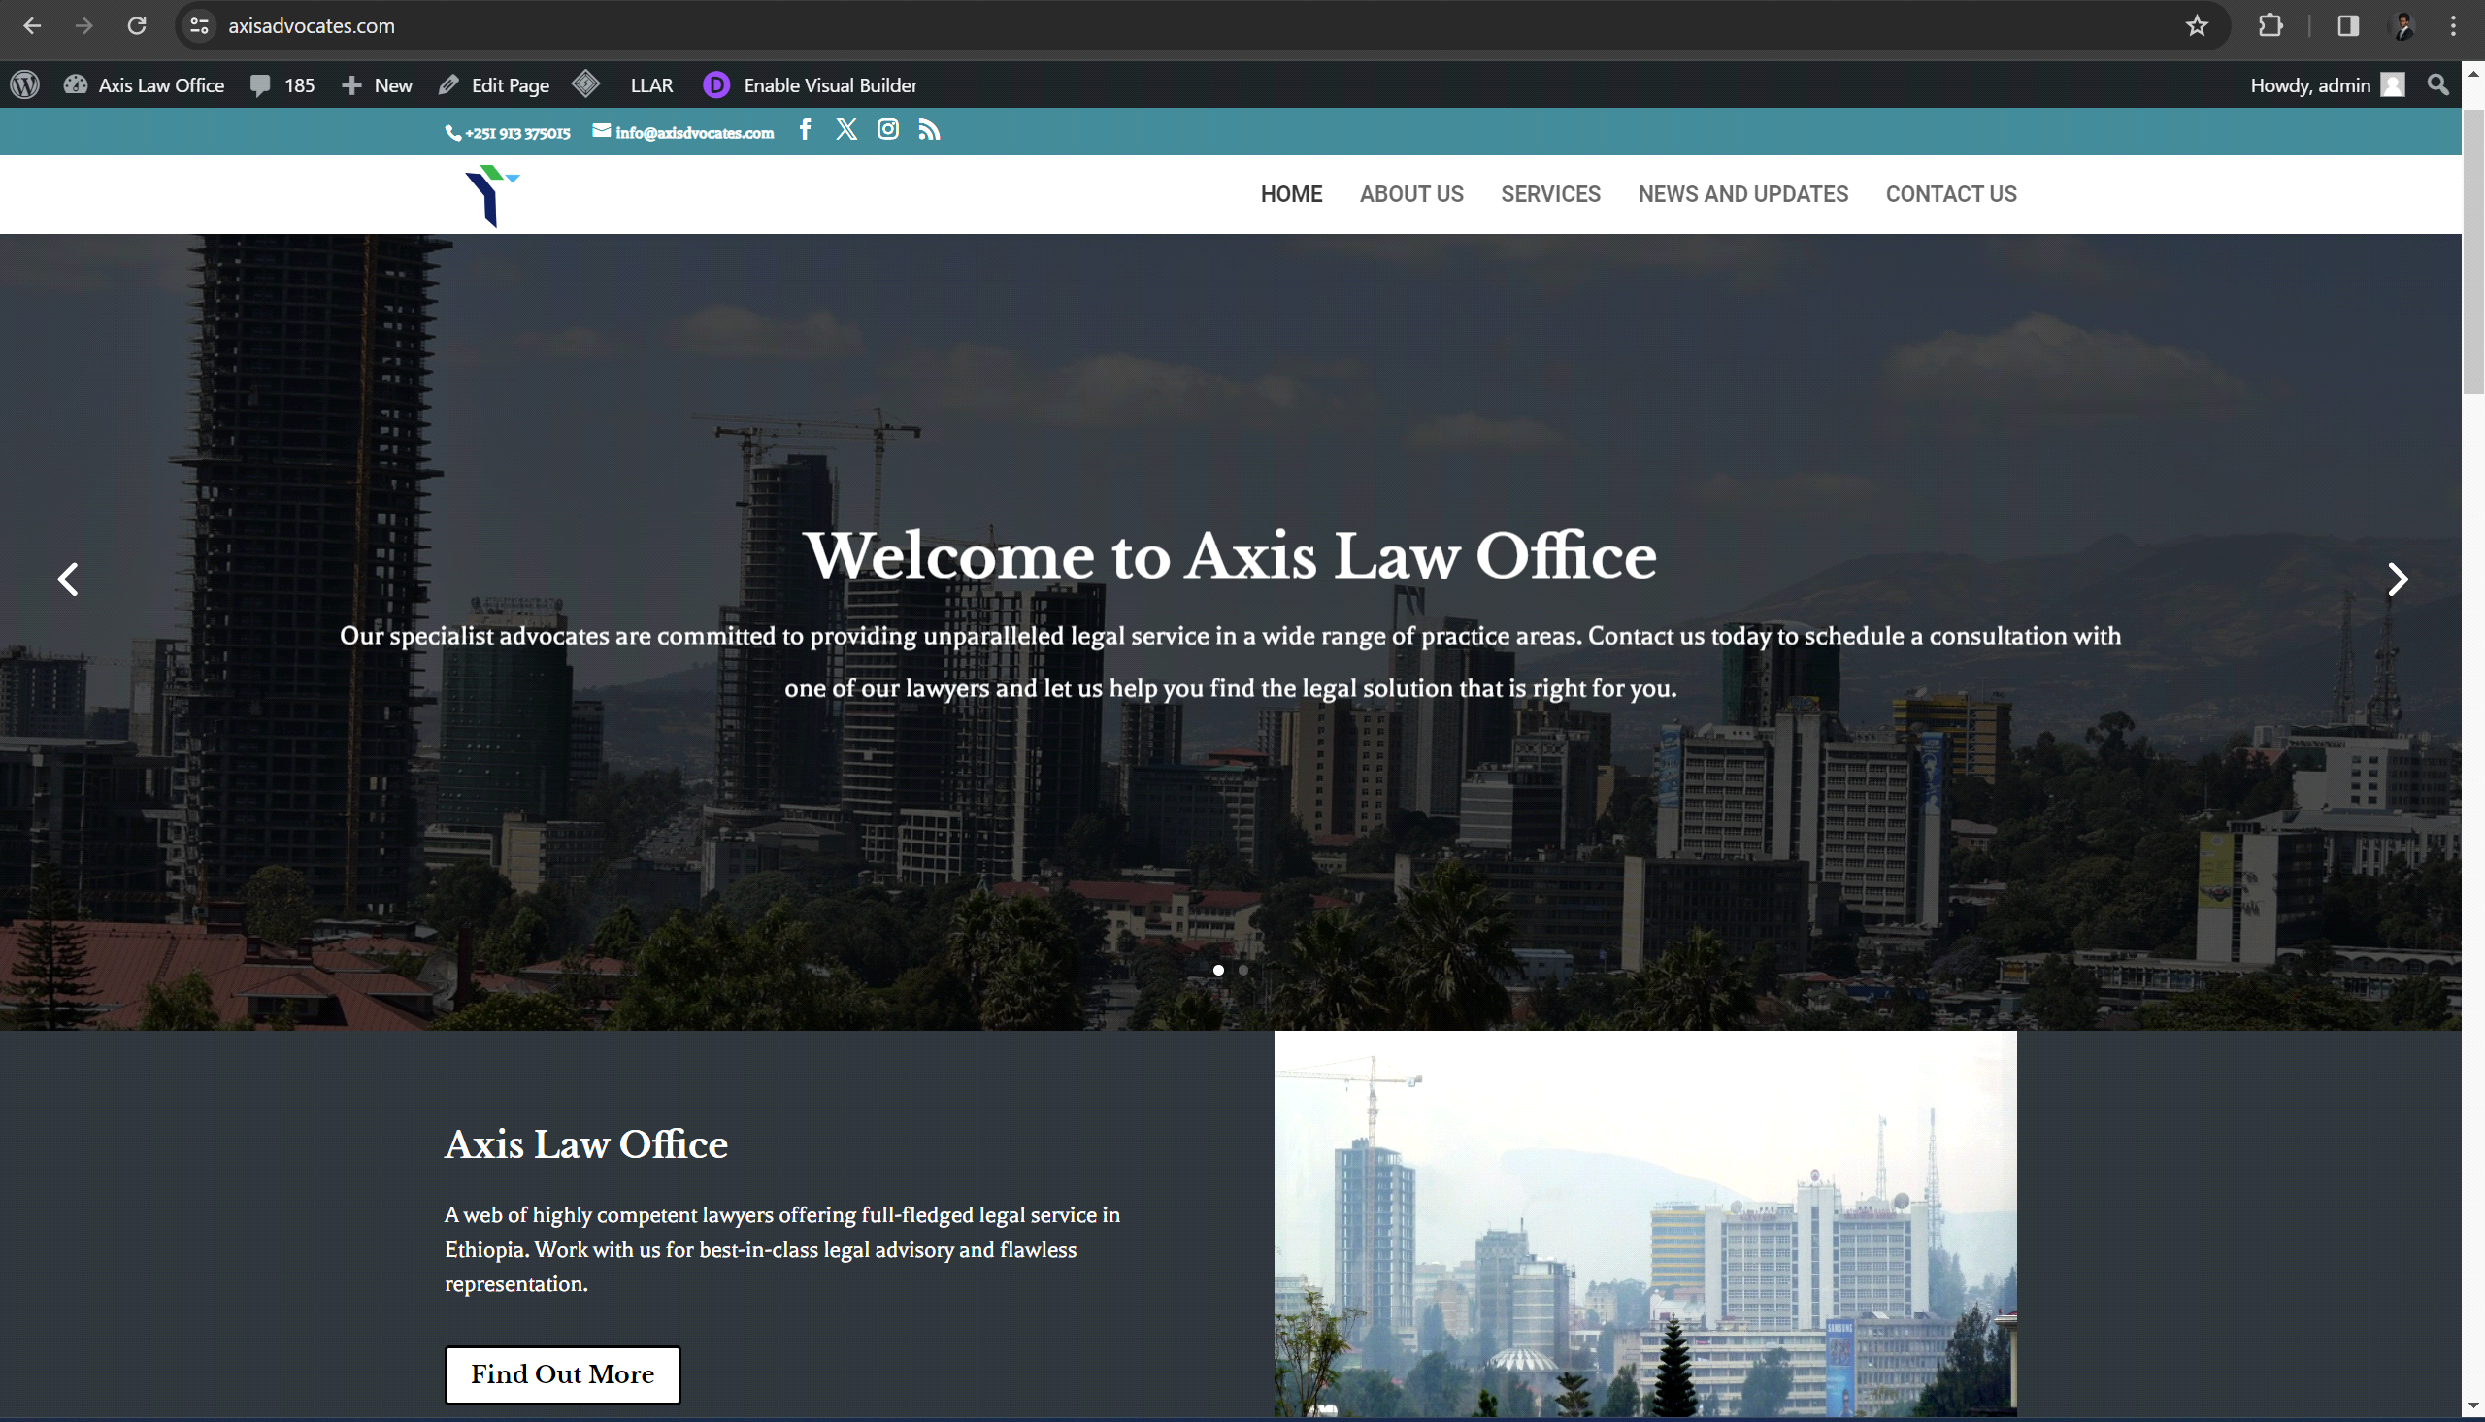

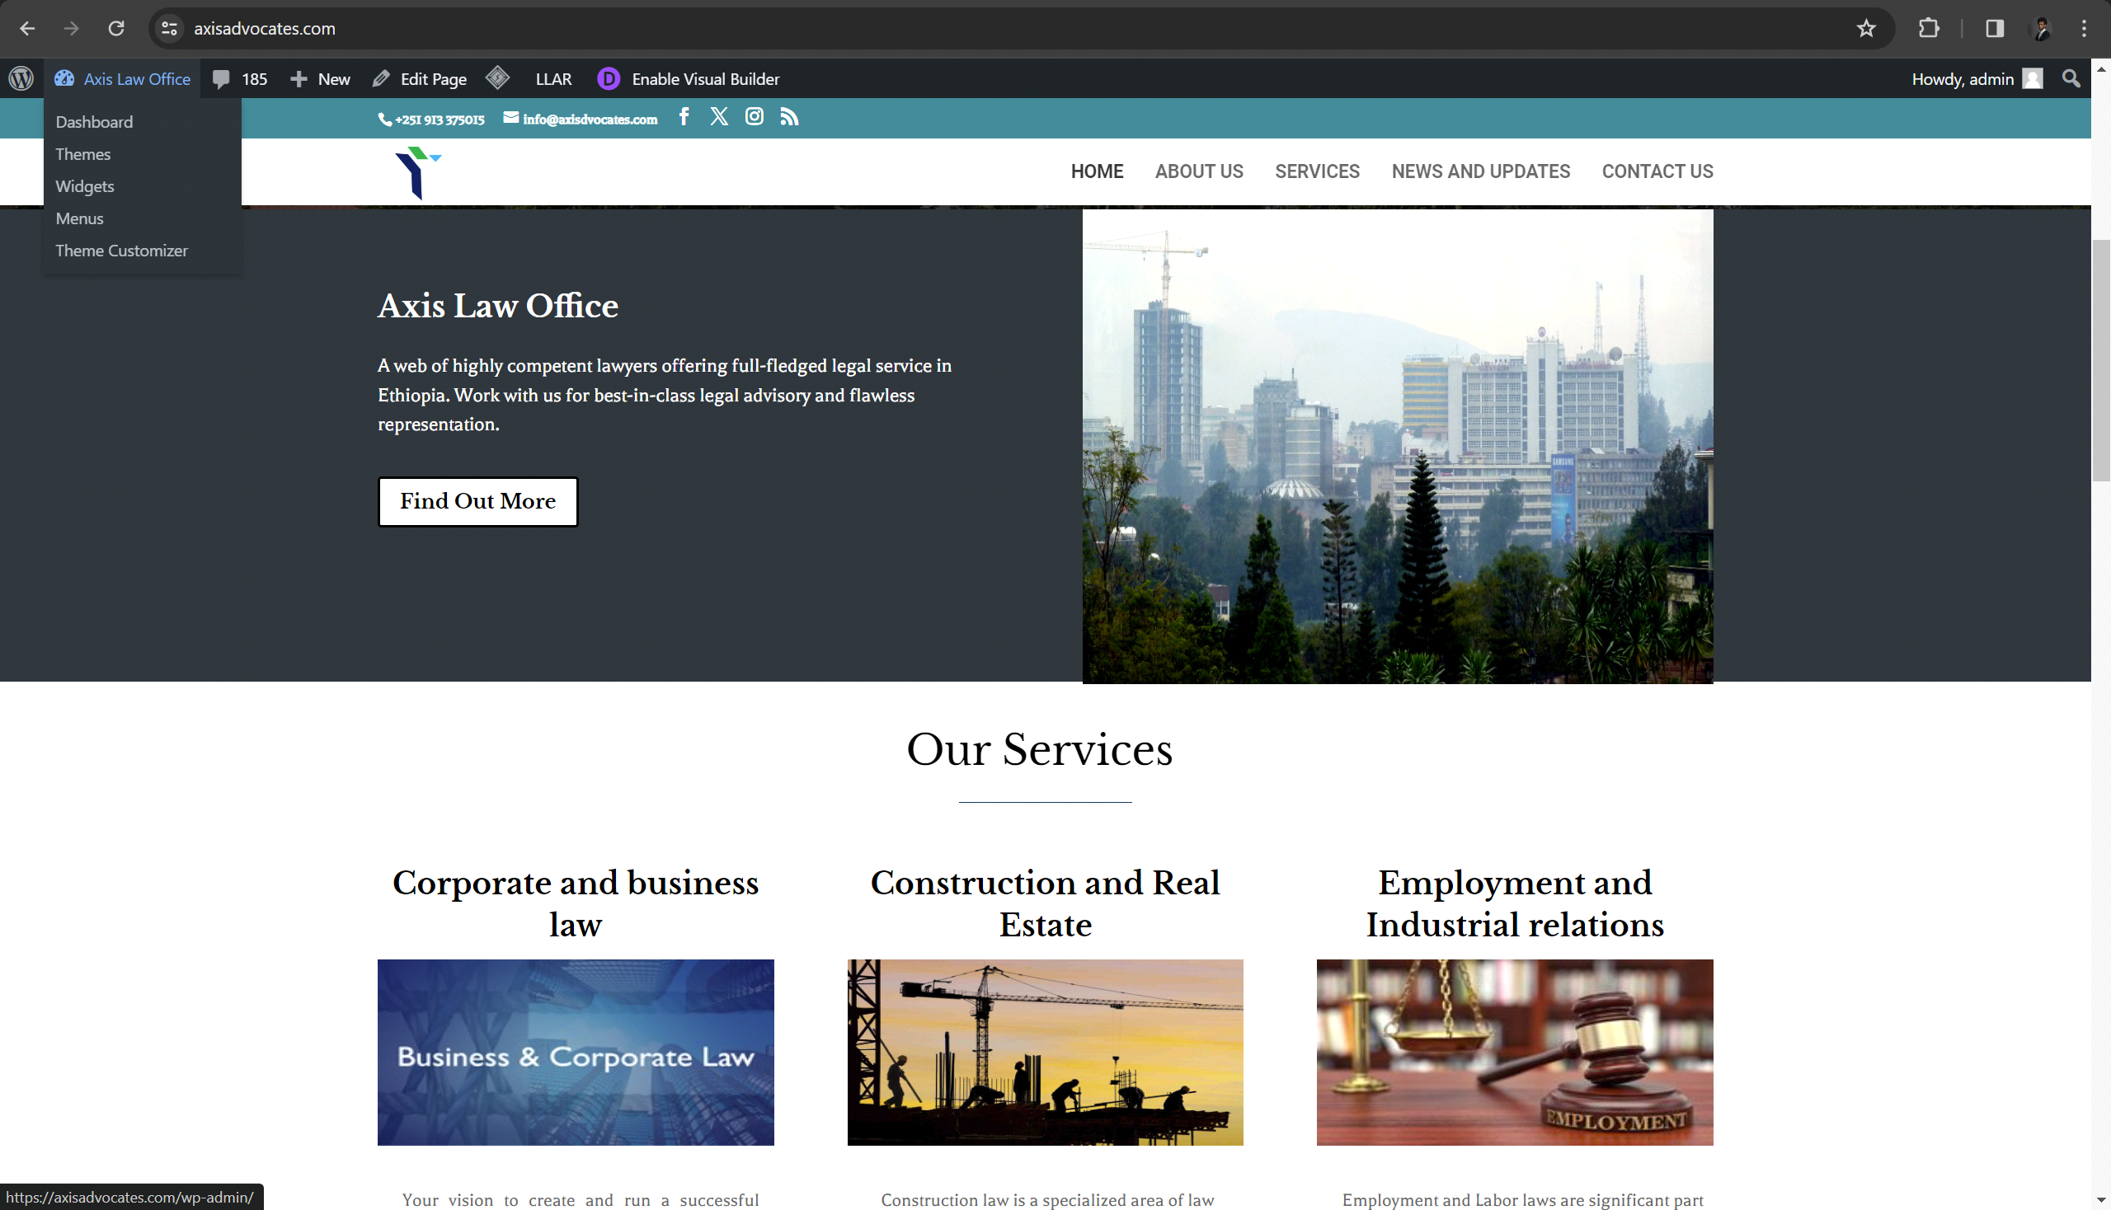

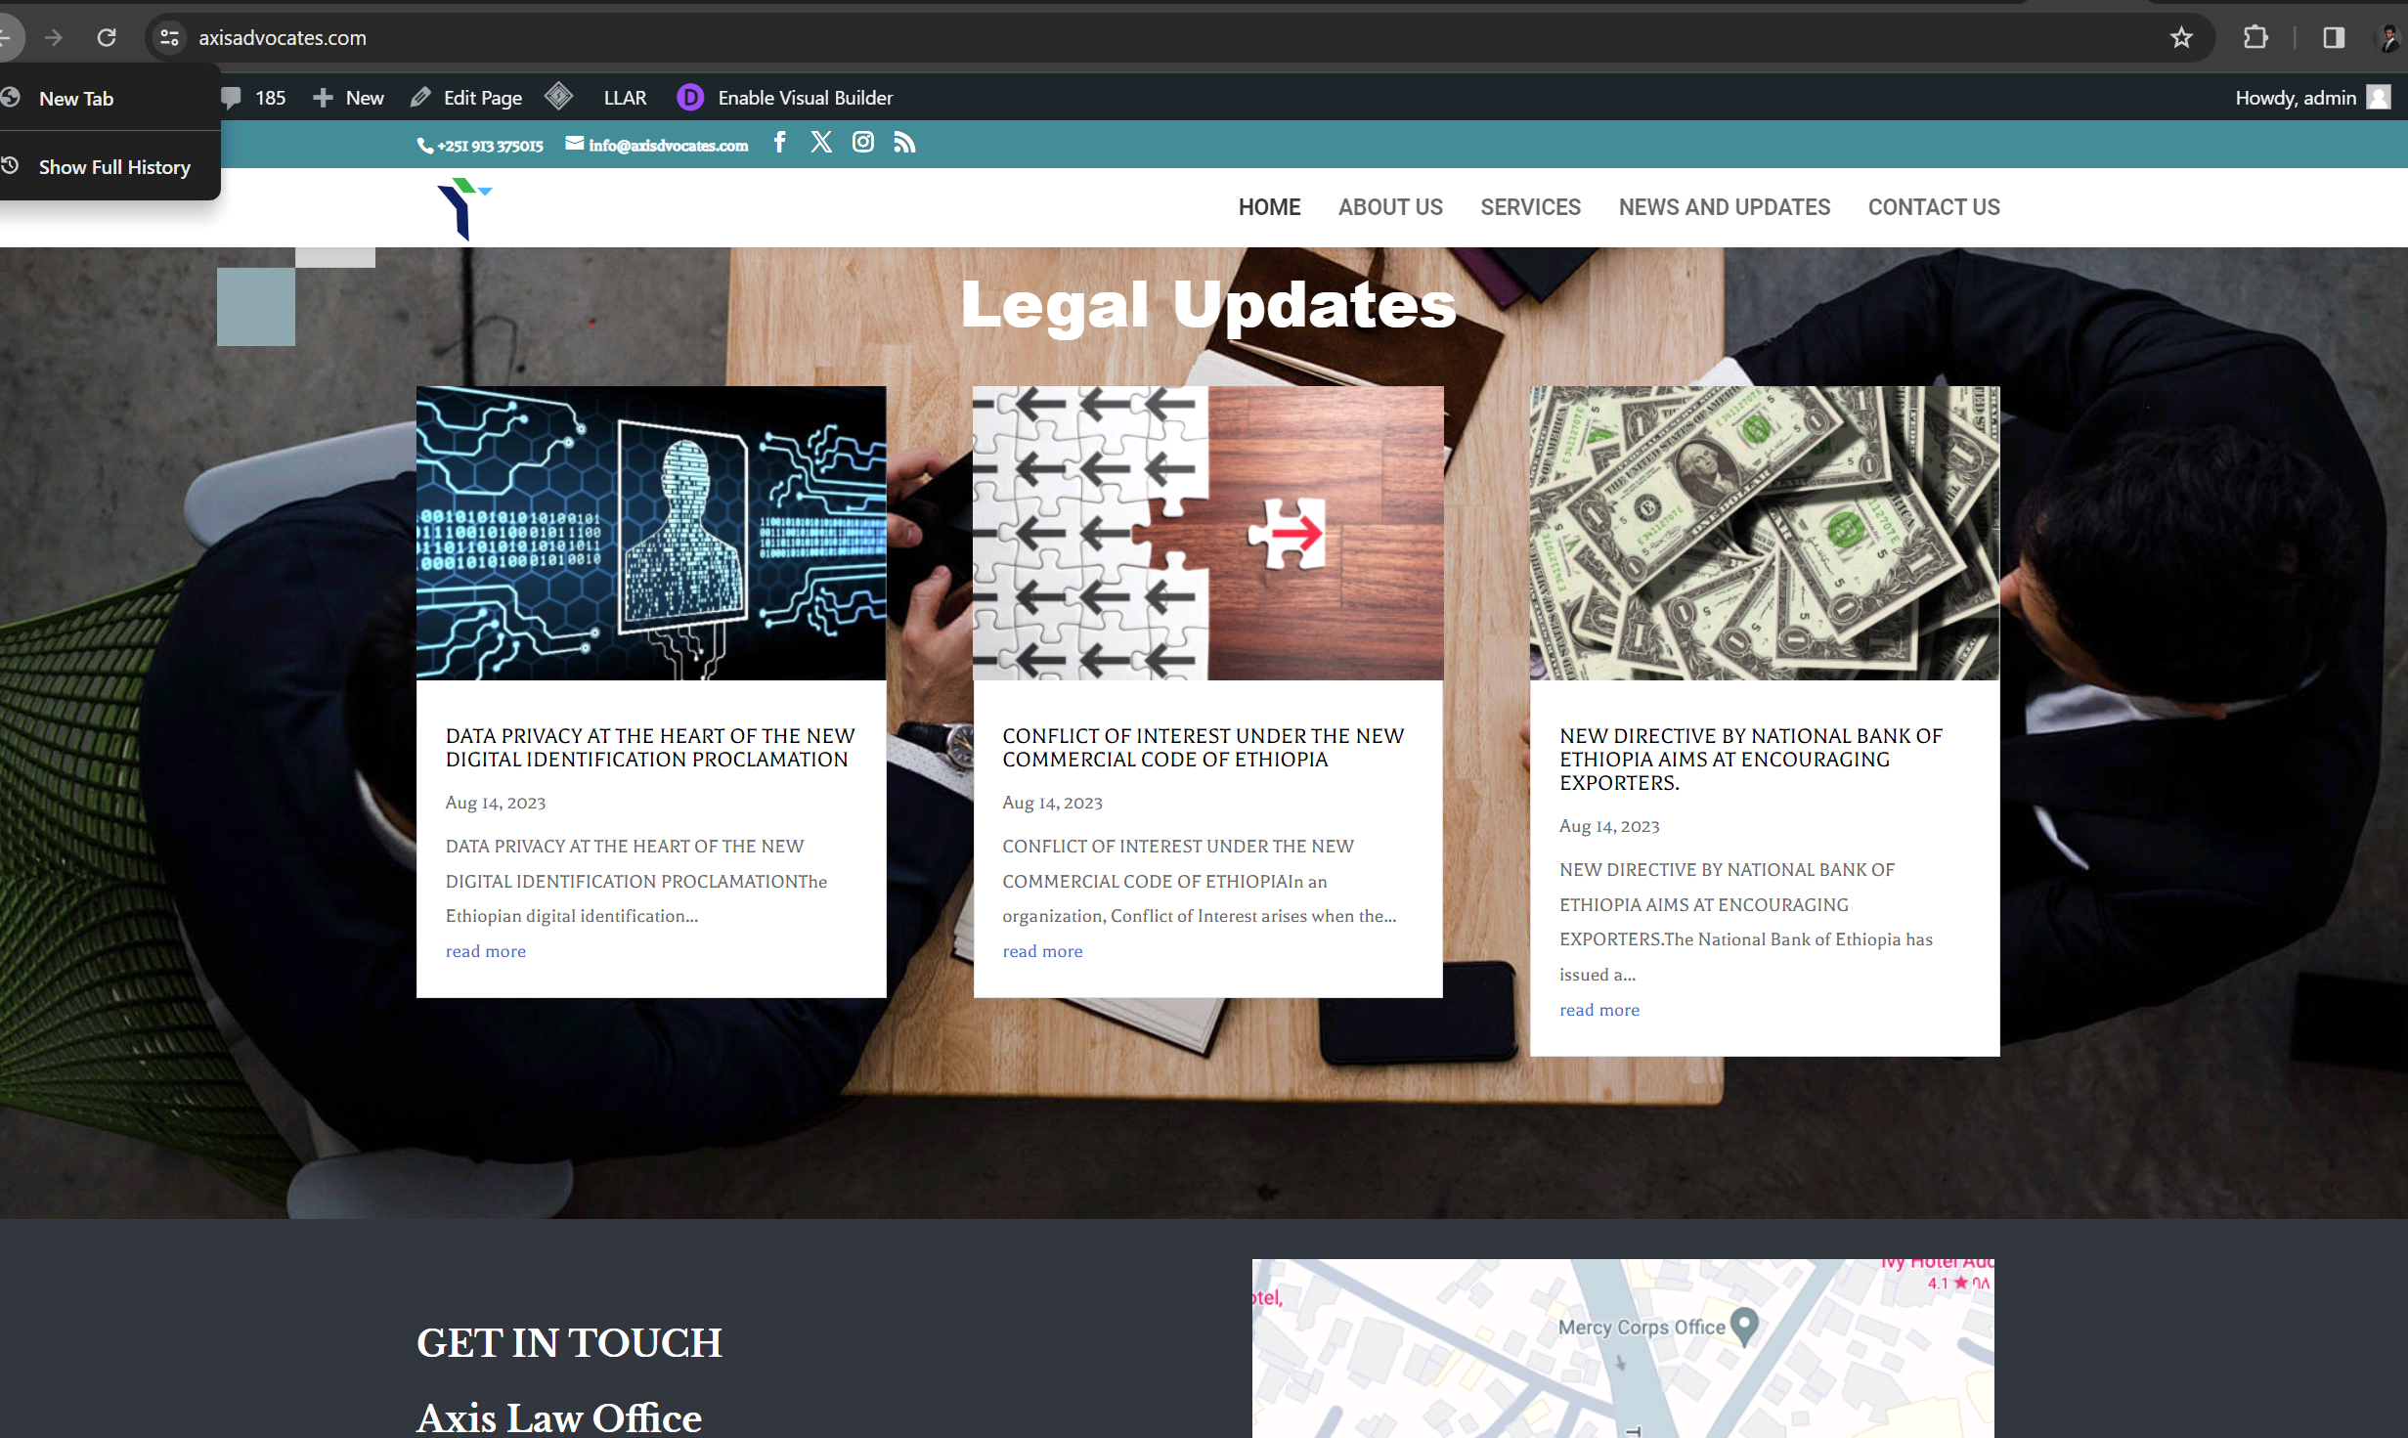

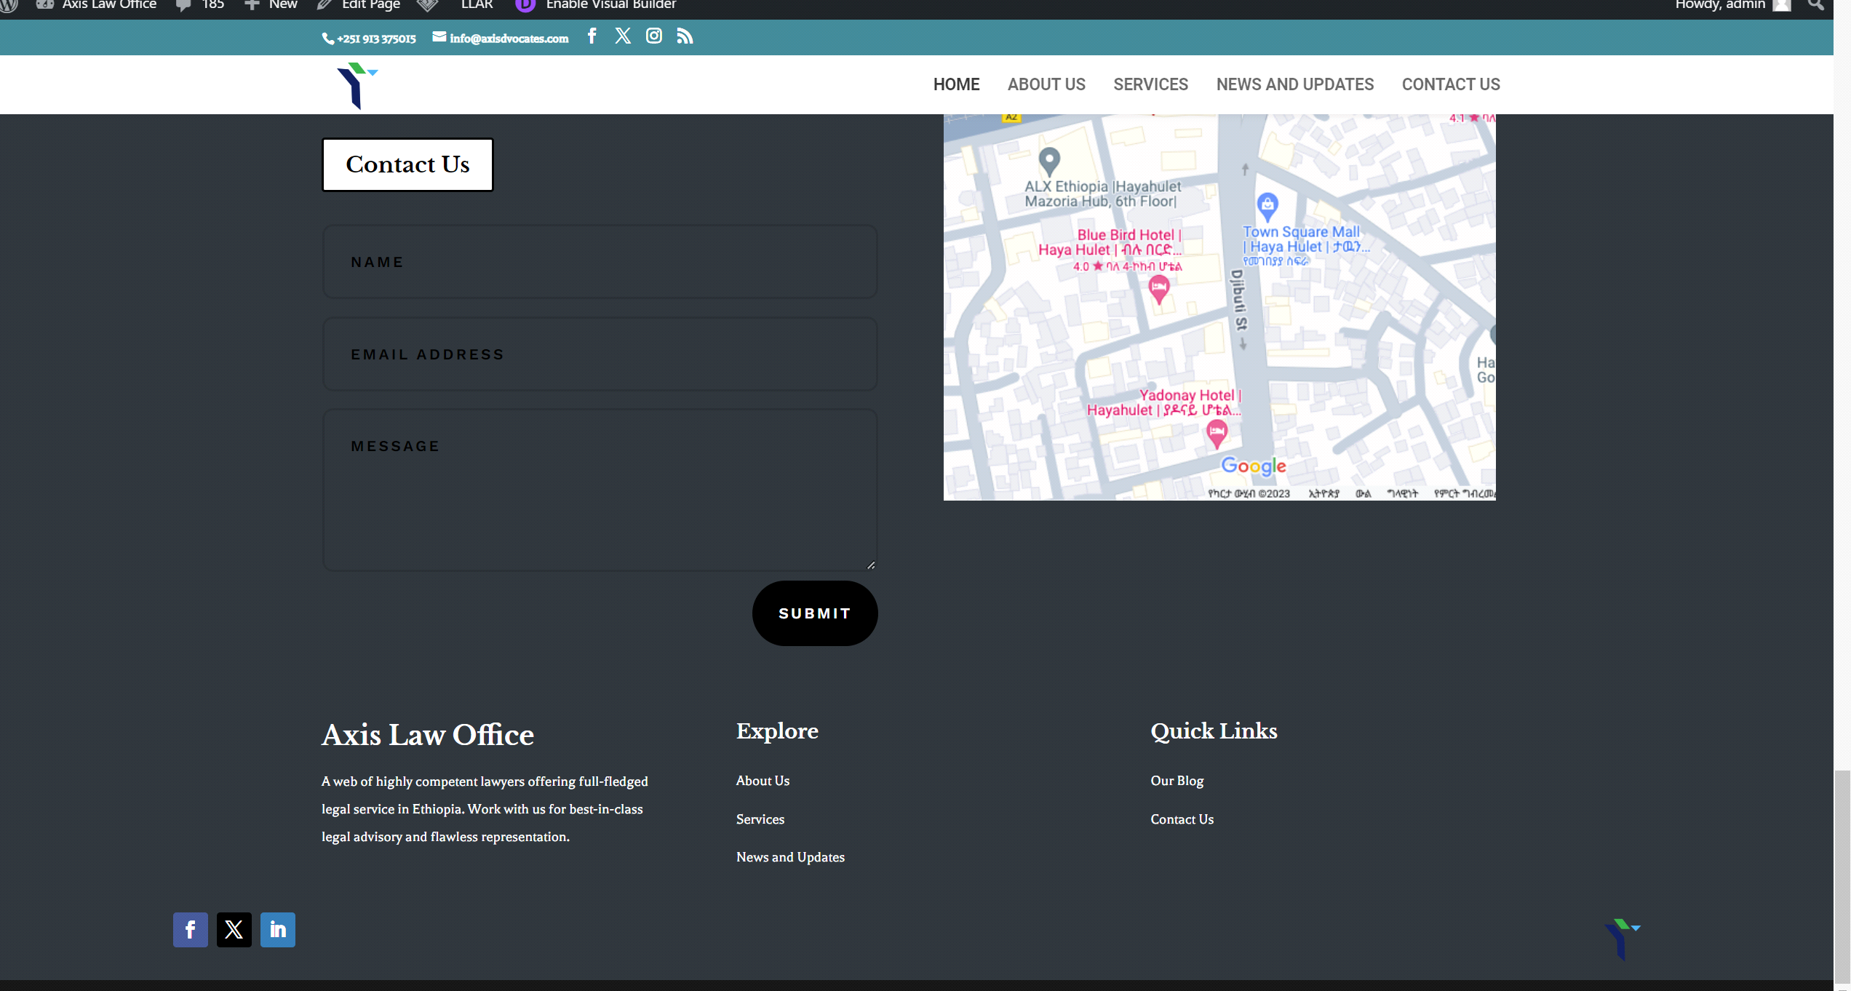

Aswale Coffee - Connecting Cultures Through the Art of Coffee

Aswale Coffee stands as a bridge between Ethiopia and Washington D.C., fostering cultural exchange through the import and export of premium Ethiopian coffee. As the developer behind their website, I aimed to create a digital platform that reflects the company's commitment to quality and tradition while facilitating seamless transactions for customers worldwide.

The website's design is inspired by the rich heritage of Ethiopian coffee culture, with earthy tones and rustic textures evoking the warmth and authenticity of traditional coffee ceremonies. Striking imagery showcases the journey of coffee beans from Ethiopia to D.C., highlighting the meticulous process of cultivation, roasting, and preparation.

A user-friendly interface allows visitors to browse the diverse selection of coffee products, learn about the company's sustainable practices, and place orders effortlessly. Integration with secure payment gateways ensures a smooth and secure checkout experience, fostering trust and confidence among customers.

By incorporating educational resources and blog content about Ethiopian coffee traditions and industry insights, the website serves as an educational hub for coffee enthusiasts and cultivates a deeper appreciation for the cultural significance of coffee.

In summary, Aswale Coffee's website embodies the company's mission to celebrate Ethiopian coffee heritage while fostering global connections, and I am honored to have contributed to its development.

website link <https://aswalecoffee.com>  
images

Elevating Letena Ethiopia's Online Presence with User-Centric Design

Letena Ethiopia's commitment to sexual and reproductive health (SRH) is commendable, and their dedication shines through their website. As the developer behind this impactful platform, I focused on creating a user-centric design that enhances accessibility and engagement.

The website's layout is intuitive, allowing visitors to navigate seamlessly through important resources, services, and information regarding SRH. Clear call-to-action buttons prompt users to explore further, ensuring they find what they need efficiently.

Through strategic use of colors, fonts, and imagery, the website communicates Letena Ethiopia's mission effectively while maintaining a professional and inviting aesthetic. By prioritizing accessibility features, including alt text for images and clear headings, the website ensures inclusivity for all users.

Overall, Letena Ethiopia's website serves as a vital online hub for SRH resources and support, and I am proud to have contributed to its development.

website link <https://www.letenaethiopia.com/>  
images

By incorporating multimedia elements such as videos and infographics, the website effectively communicates the impact of health partnerships and inspires visitors to get involved. Robust backend functionality enables administrators to manage content efficiently and keep the website updated with the latest developments.